OBJECT ORIENTED PROGRAMMING USING JAVA

NAME : DIVYA.K

DEPT & SEC : CSE & B

ROLL NO : 230701082

WEEK :10

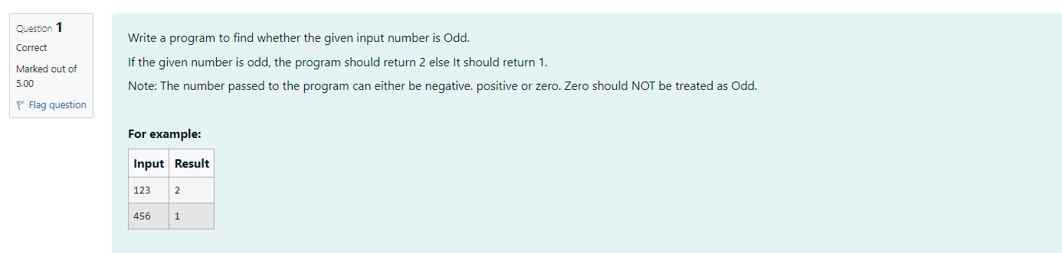

import java.util.\*;

public class Odd{

public static void main(String args[])

{

Scanner a=new Scanner(System.in);

int b=a.nextInt();

if(b%2!=0 && b!=0)

{

System.out.print("2");

}

else{

System.out.print("1");

}

}

}

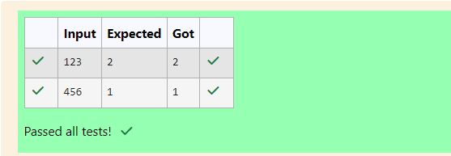

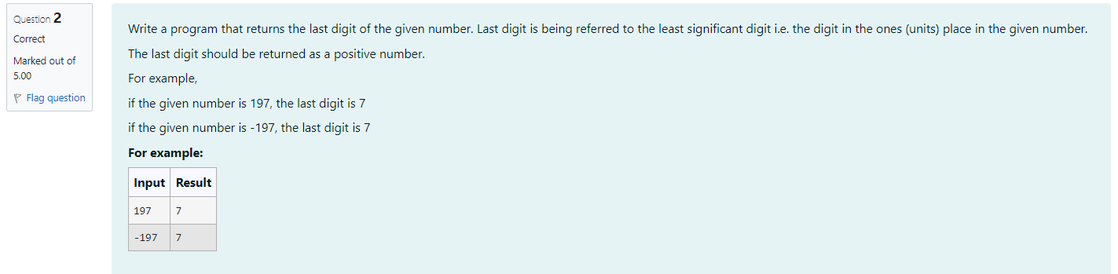

import java.util.\*;

public class Rev

{

public static void main(String[] args){

Scanner a-new Scanner(System.in);

int b-a.nextInt();

int c-b%10;

System.out.print(Math.abs(c));

}

}

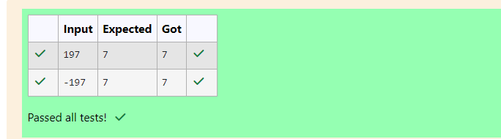

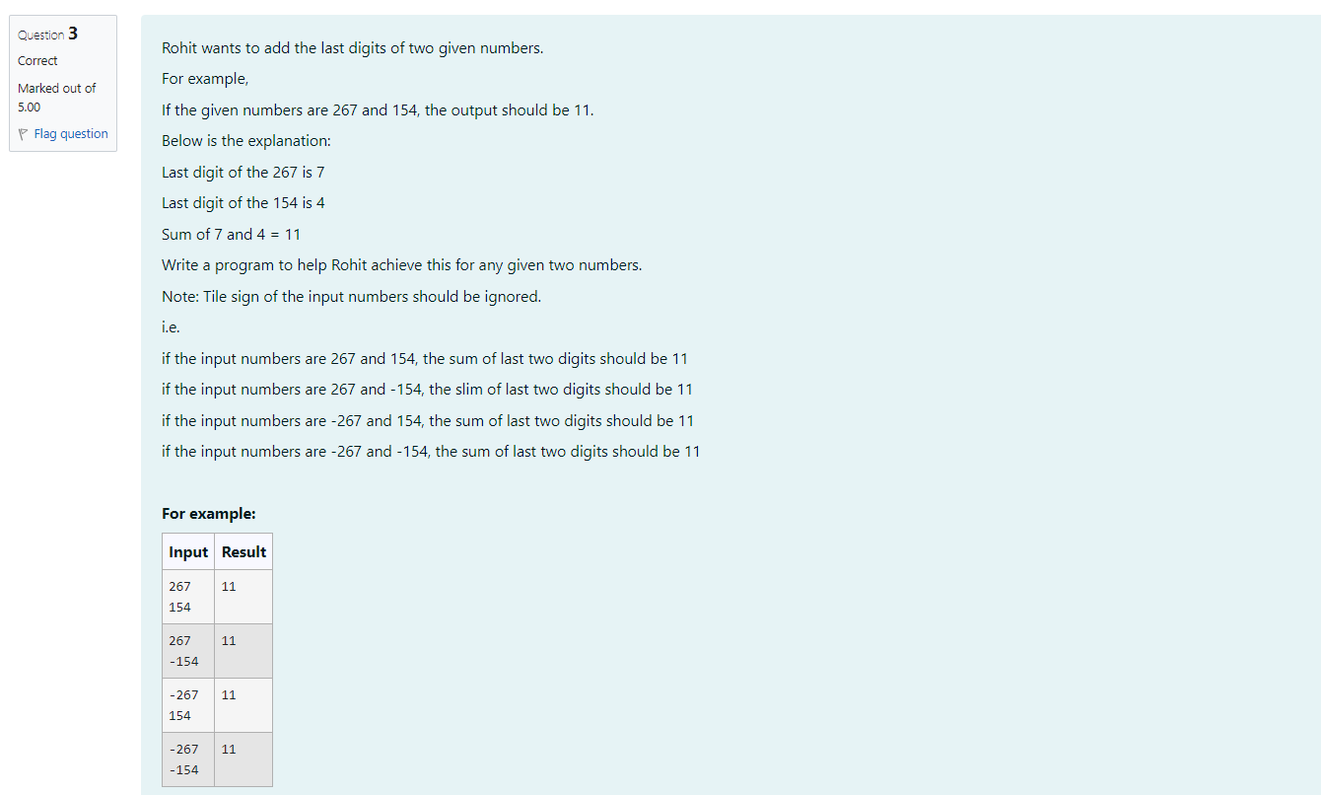

import java.util.\*;

public class Num{

public static void main(String[] args) {

Scanner a=new Scanner(System.in);

int b=a.nextInt();

int c=a.nextInt();

int j=Math.abs(b%10);

int m-Math.abs(c%10);

System.out.print(j+m);

}

}

